2020

Lenten Communal Penance Service

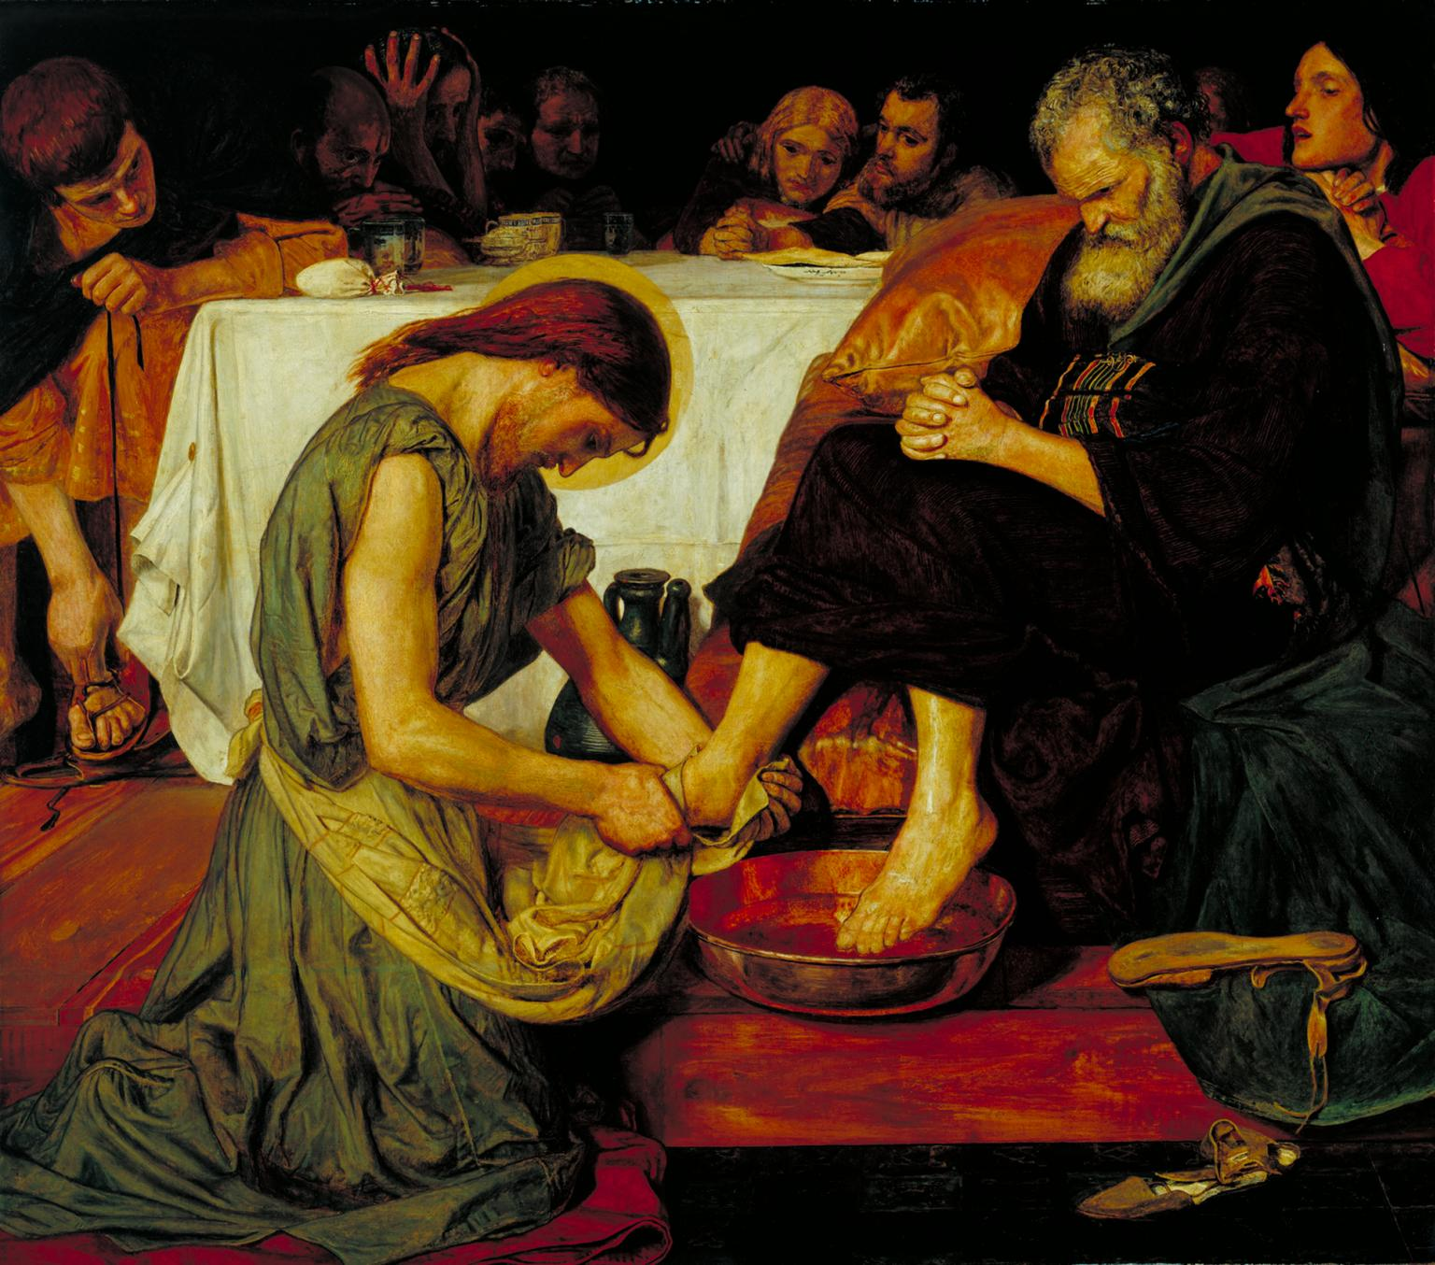

*Jesus Washing Peter’s Feet*

by Ford Madox Brown, 1852-1856

Tate Gallery, London

Introductory Rites

Hymn

**Lord, who throughout these forty days  
For us did fast and pray,  
Teach us to overcome our sins  
And close by you to stay.**

**As you with Satan did contend,  
And did the vict’ry win,  
O give us strength in you to fight,  
In you to conquer sin.**

**As you did hunger and did thirst,  
So teach us, gracious Lord,  
To die to self, and so to live  
By your most holy Word.**

Text: Claudia F. Hernaman, 1838-1898, alt.  
Tune: ST. FLAVIAN, CM; *Johns’s Day Psalter*, 1562

In the Public Domain

Greeting

*To which the people respond:*

**All: Glory to him for ever. Amen**

Opening Prayer

The Liturgy of the Word

First Reading Isaiah 53:1-7, 10-12

*In conclusion:*

Reader: The word of the Lord.

**All: Thanks be to God.**

Responsorial Psalm Psalm 51, 3-4, 5-6. 12-13. 14. 17.

**R. Be merciful, O Lord, for we have sinned.**

Gospel Mark 10: 32-45

*Prior to the reading:*

Deacon: The Lord be with you.

**All: And with your spirit.**

Deacon: A reading from the holy gospel according to Mark>

**All: Glory to you, Lord.**

*In conclusion:*

Deacon: The gospel of the Lord.

**All: Praise to you, Lord Jesus Christ.**

Homily

Examination of Conscience

*The assembly is now invited to make an examination of conscience.*

*This may be done in silence or by using the examination of conscience below.*

*One reader alone may read the questions or two readers might alternate.*

*Allow a brief period of silence between each one.*

**Reader(s):**

* Where is my life really leading me? Is the hope of eternal life my inspiration?
* Have I tried to grow in the life of the Spirit through prayer, reading the word of God, receiving the sacraments?
* Have I imposed my own will on others, without respecting their freedom and rights?
* What use have I made of time, of health and strength, of the gifts God has given me? Do I use them to become more perfect each day?
* Have I been patient in accepting the sorrows and disappointments of life?
* Have I kept my whole body pure as a temple of the Holy Spirit?
* Have I dishonored my body physically or through unworthy conversation or thoughts?
* Have I indulged in activities which offend Christian or human decency?
* Have I gone against my conscience out of fear or hypocrisy?

*If read aloud, this Examination of Conscience should conclude with a period of silence so that each person may personally examine his or her conscience.*

Rite of Reconciliation

General Confession of Sins

*After a brief period of silence, all say together:*

**I confess to almighty God  
and to you, my brothers and sisters,  
that I have greatly sinned  
in my thoughts and in my words,  
in what I have done  
and in what I have failed to do,**

*[All strike their breast]*

**through my fault, through my fault,  
through my most grievous fault;  
therefore I ask blessed Mary ever-Virgin,  
all the Angels and Saints,  
and you, my brothers and sisters,  
to pray for me to the Lord our God.**

Litany of Repentance

*After a brief introduction, all recite alternatingly:*

Presider: Give us the grace of true repentance.

**All: Hear us, O Lord.**

Presider: Pardon us, your servants

**All: —and release us from the debt of sin.**

Presider: Forgive your children who confess their sins,

**All: —and restore us to full communion with your Church.**

Presider: Renew the glory of our common baptism,

**All: —which has been impoverished by sin.**

Presider: Welcome us to your altar

**All: —and renew our spirit with the hope of eternal glory.**

Presider: Keep us faithful to your sacraments

**All: —and loyal in your service.**

Presider: Renew your love in our hearts

**All: —and help us bear witness to it in our daily lives.**

Presider: Keep us always obedient to your commandments

**All: —and protect within us your gift of eternal life.**

Lord’s Prayer

Invitation to Individual Confession

Prayer and Blessing

*Confessors process to their stations during the song.*

Hymn

**Come, you sinners, poor and needy,  
Weak and wounded, sick and sore;  
Jesus, Son of God, will save you,  
Full of pity, love and pow’r.**

*Refrain*

**I will arise and go to Jesus,  
He will embrace me in his arms;  
In the arms of my dear Savior,  
Oh, there are ten thousand charms.**

**Come, you thirsty, come, and welcome,  
God’s free bounty glorify:  
True belief and true repentance,  
Ev’ry grace that brings you nigh.** *Refrain*

**Come, you weary, heavy laden,  
Lost and ruined by the fall;  
If you tarry till you’re better,  
You will never come at all.**  *Refrain*

Text: Joseph Hart, 1712-1768, alt.  
Tune: RESTORATION, 8 7 8 7 with refrain; *Southern Harmony*, 1835

In the Public Domain

Individual Confession and Absolution

*Then the penitents go to the priests designated for individual confession, and confess their sins. Each one receives and accepts a fitting act of satisfaction and is absolved. After hearing the confession and offering suitable counsel, the priest extends his hands over the penitent’s head (or at least extends his right hand) and gives him or her absolution. Everything else which is customary in individual confession is omitted.*

*After receiving absolution the penitents may return to the main body of the church and spend some time in private prayer, but are otherwise dismissed.*

*Soft, unobtrusive instrumental music may be played for a time during the transition to individual confession.*