2019
Lenten Communal Penance Service

Introductory Rites

Hymn
STAND

In Christ there is no east or west,
In him no south or north,
But one community of love
Throughout the whole wide earth.
In Christ shall true hearts ev'rywhere
Their high communion find;
His service is the golden cord
Close binding human kind.
Join hands, disciples of the faith,
Whate'er your race may be.
All children of the living God
Are surely kin to me.
In Christ now meet both east and west,
In him meet south and north;
All Christly souls are one in him
Throughout the whole wide earth.

Text: Galatians 3:23; William A. Dunkerly, 1852-1941
Tune: McKEE, CM; African American; adapt. by Harry T. Burleigh, 1866-1949

Greeting

Brief Introduction/Explanation

Opening Prayer

The Liturgy of the Word
SIT
First Reading Isaiah 58: 6-7

Responsorial Psalm Psalm 25: 4-5a, 6-7, 8-9

R. Your ways, O Lord, are love and truth,
to those who keep your covenant.

Gospel Acclamation
STAND

Gospel Matthew 25: 34-40

Homily
SIT

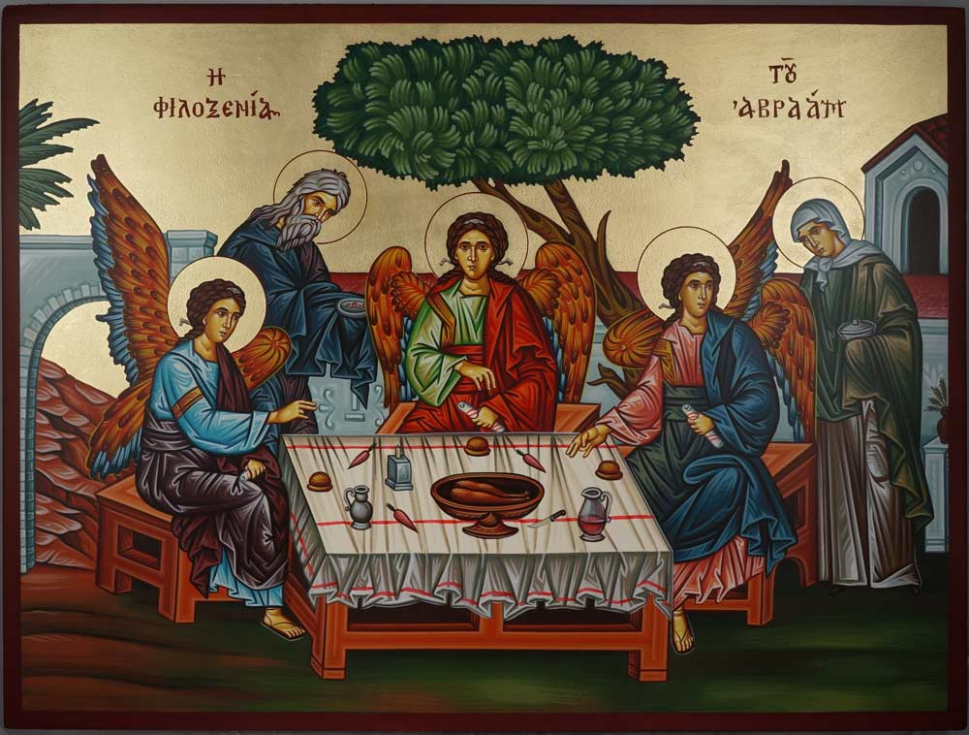

Hospitality of Abraham

(Holy Trinity—Abraham and Sarah)
Hand-painted icon – landscape.

https://www.blessedmart.com/shop/hand-painted-icons/hospitality-of-abraham-holy-trinity-landscape/
Examination of Conscience

The assembly is now invited to make an examination of conscience.

This may be done in silence or by using a text which is read aloud.

If read aloud, this Examination of Conscience should conclude with a period of silence so that each person may personally examine his or her conscience.

Rite of Reconciliation
STAND

General Confession of Sins

After a brief period of silence, all say together:

I confess to almighty God
and to you, my brothers and sisters,
that I have greatly sinned
in my thoughts and in my words,
in what I have done
and in what I have failed to do,
[All strike their breast]
through my fault, through my fault,
through my most grievous fault;
therefore I ask blessed Mary ever-Virgin,
all the Angels and Saints,
and you, my brothers and sisters,
to pray for me to the Lord our God.

Lord’s Prayer

Invitation to Individual Confession
SIT

Hymn
STAND
My life flows on in endless song;
Above earth's lamentation
I hear the sweet though far off hymn
That hails a new creation:
Through all the tumult and the strife
I hear the music ringing;
It finds an echo in my soul-
How can I keep from singing?

What though my joys and comforts die?
The Lord my Savior liveth;
What though the darkness gather round!
Songs in the night He giveth:
No storm can shake my inmost calm
While to that refuge clinging;
Since Christ is Lord of heaven and earth,
How can I keep from singing?

I lift mine eyes; the cloud grows thin;
I see the blue above it;
And day by day this pathway smoothes
Since first I learned to love it:
The peace of Christ makes fresh my heart,
A fountain ever springing:
All things are mine since I am His-
How can I keep from singing?

Text: Robert Lowry, 1826-1899
Tune: HOW CAN I KEEP FROM SINGING, 8 7 8 7 D; Ira David Sankey, 1840-1908

Individual Confession and Absolution

Then the penitents go to the priests designated for individual confession, and confess their sins. Each one receives and accepts a fitting act of satisfaction and is absolved. After hearing the confession and offering suitable counsel, the priest extends his hands over the penitent’s head (or at least extends his right hand) and gives him or her absolution. Everything else which is customary in individual confession is omitted.

After receiving absolution the penitents may return to the main body of the church and spend some time in private prayer, but are otherwise dismissed.

